

***NAMAL UNIVERSITY MIANWALI***

***DEPARTMENT OF ELECTRICAL ENGINEERING***

***EE 345 (L) – Digital Signal Processing (Lab)***

***LAB # 10***

***REPORT***

***Title : FIR and IIR Filter Design in MATLAB***

|  |  |
| --- | --- |
| ***Name*** | ***Fahim Ur Rehman Shah*** |
| ***Roll No*** | ***NIM-BSEE-2021-24*** |
| ***Intructor*** | ***Zulaikha Kiran*** |
| ***Lab Engineer*** | ***Engr. Faizan Ahmad*** |
| ***Date Performed*** | ***May 23, 2024*** |
| ***Marks*** |  |

# Introduction

The purpose of this lab is to enable the students to design FIR and IIR filters using MATLAB Filter Designer App, and apply it on a signal in their code.

# Course Learning Outcomes

CLO1: Develop algorithms to perform signal processing techniques on digital signals using MATLAB and DSP Kit DSK6713

CLO3: Deliver a report/lab notes/presentation/viva, effectively communicating the design and analysis of the given problem

# Equipment

• Software

o MATLAB

# Instructions

1. This is an individual lab. You will perform the tasks individually and submit a report.
2. Some of these tasks are for practice purposes only while others (marked as ‘Exercise’) have to be answered in the report.
3. When asked to display an image/ graph in the exercise either save it as jpeg or take a screenshot, in order to insert it in the report.
4. The report should be submitted on the given template, including:
   1. Code (copy and pasted, NOT a screenshot)
   2. Output values (from command window, can be a screenshot)
   3. Output figure/graph (as instructed in 3)
   4. Explanation where required
5. The report should be properly formatted, with easy to read code and easy to see figures.
6. Plagiarism or any hint thereof will be dealt with strictly. Any incident where plagiarism is caught, both (or all) students involved will be given zero marks, regardless of who copied whom. Multiple such incidents will result in disciplinary action being taken.

## Background

The goal of filtering is to perform frequency-dependent alteration of a signal. A simple design specification for a filter might be to remove noise above a certain cut-off frequency. A more complete specification might call for a specific amount of pass band ripple (Rp, in decibels). Stop band attenuation (Rs, in decibels), or transition width (Wp-Ws, in hertz).

Digital filter specifications are often given is terms of the loss function (in dB),

A (ω) =−20log10|G (ejw)|

The Filter Designer tool of MATLAB allows to design and edit IIR and FIR filters of various lengths and types, with lowpass, highpass, bandpass, and bandstop configurations. It also allows export of the designed filter to workspace or Simulink.

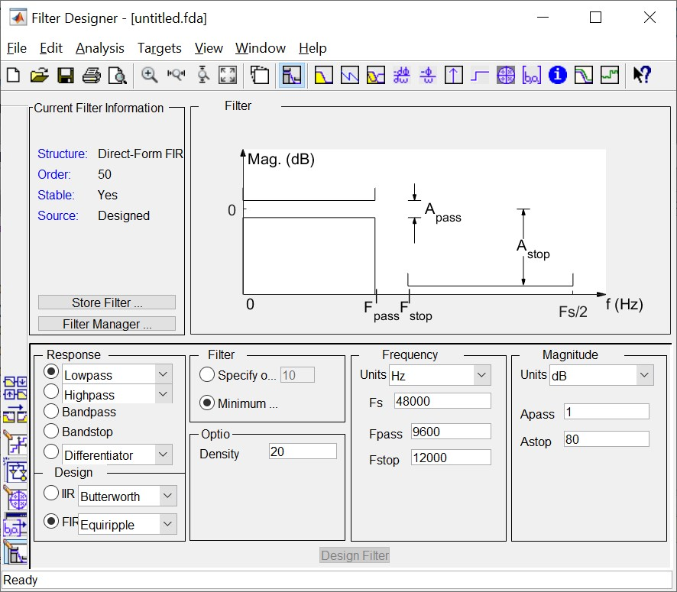

*Figure 1: Filter Designer GUI*

Once a filter has been designed using this GUI, it can be exported to the workspace by going to File > Export and choosing to export it as objects, so that it can be applied directly in the filter function.

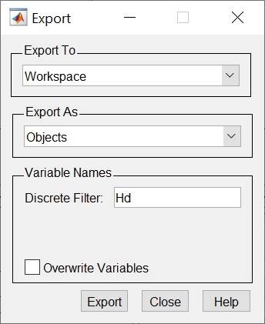

Open the filter designer in MATLAB either from the Apps, or by entering filterDesigner in the command window.

### Exercise 1

1. Design a low pass, FIR Equiripple filter with minimum order keeping sampling frequency Fs=1000 Hz, Fpass=110, Fstop=200, Apass =1dB, Astop =80dB.



1. Plot the magnitude response. Describe it.
2. Look at dφ/dω called the group delay. Describe the group delay and its significance.
3. Plot the impulse response of designed filter and write your comments.
4. Plot the pole zero map of designed filter and write your comments.
5. Export the filter to your workspace.

***Magnitude Response:***

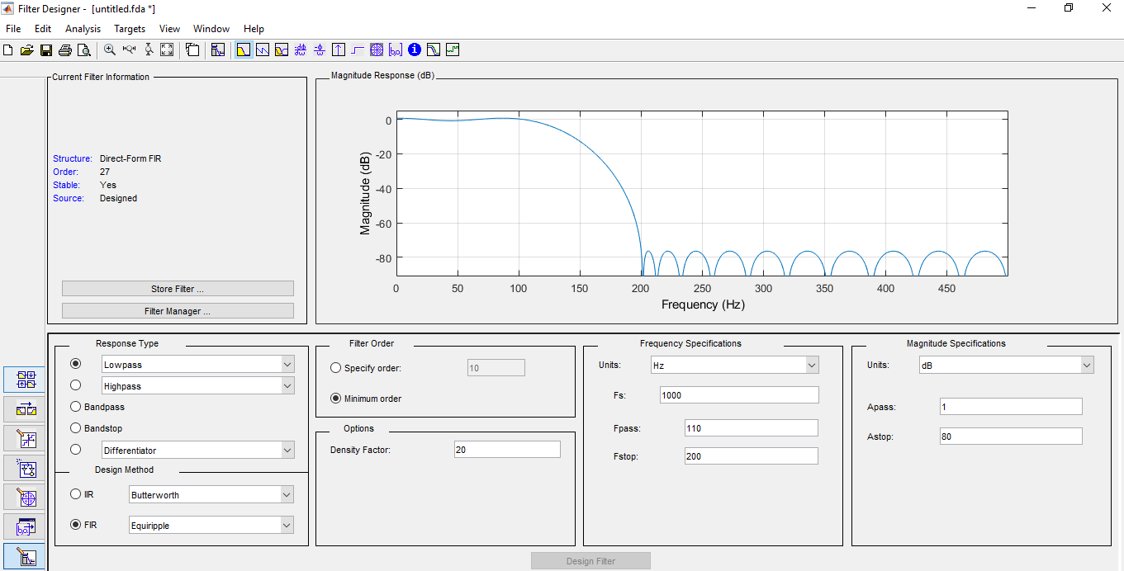

***Group Delay dφ/dω:***

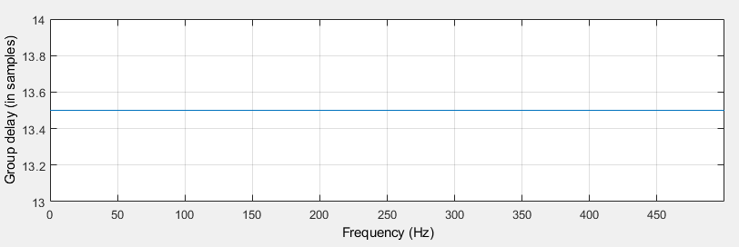

***Impulse response:***

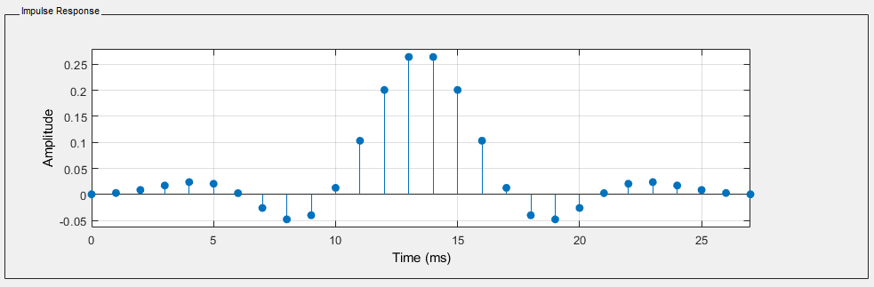

***Pole-Zero Plot:***

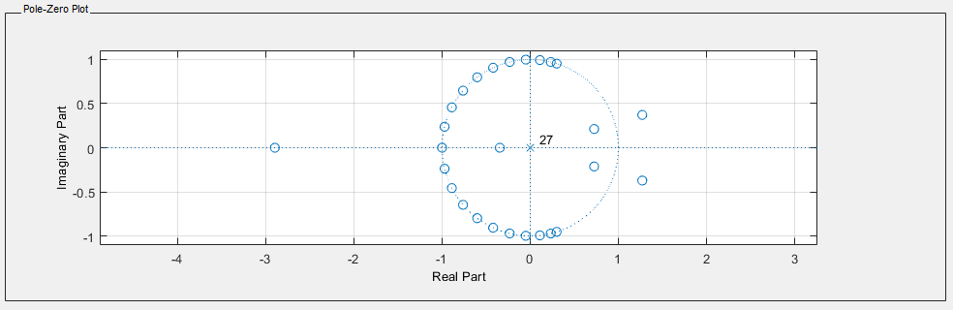

***Explanation:***

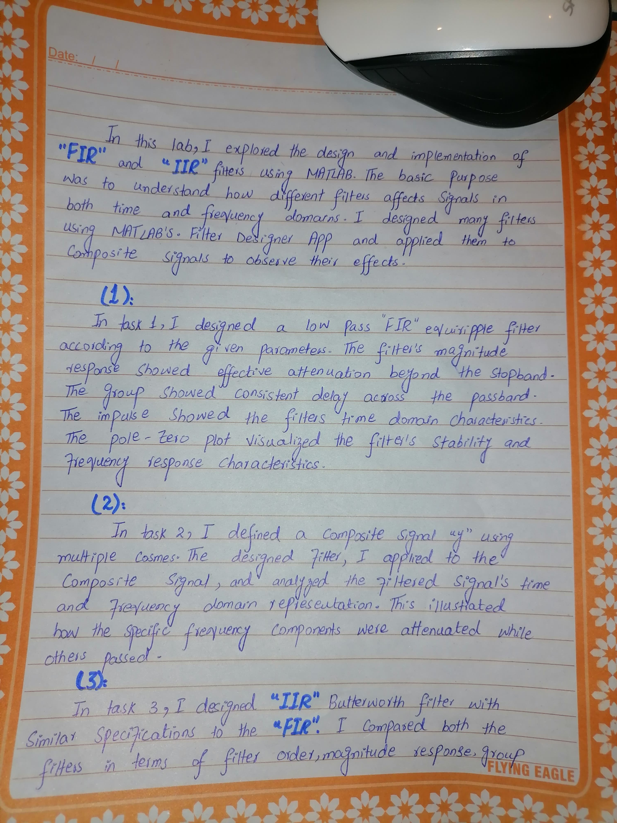



**Exercise**

**2**

Define

a signal

y

using

the following

code:

fs

=

1000

;

f1

=

100

;

f2

=

200

;

f3

=

300

;

t

=

0:(1

/fs):(100/f

3)

-

(1

/fs);

x1=1*cos(2*pi*f1*t);

x2=2*cos(2*pi*f2*t);

x3=3*cos(2*pi*f3*t);

y

=

x1+x2+x3;

Plot the signal, as well as its frequency response.

Apply the filter designed in Task 1 to this signal using the filter(_) function.



Explain the output using time as well as frequency domain representations.

|  |
| --- |
| **MATLAB Code:**  clc, clear all:  % Define parameters  fs = 1000;  f1 = 100;  f2 = 200;  f3 = 300;  % Time vector  t = 0:1/fs:(100/f3)-(1/fs);  % Generate signals  x1 = 1*cos(2*pi*f1*t);  x2 = 2*cos(2*pi*f2*t);  x3 = 3*cos(2*pi*f3*t);  y = x1 + x2 + x3;  % Plot original signal in time domain  figure(1);  subplot(2, 1, 1);  plot(t,y);  xlabel('Time (s)');  ylabel('Signal Amplitude');  title('Original Signal');  % Calculate frequency response of original signal (FFT)  Y = fft(y);  f = linspace(0, fs/2, length(Y)/2+1);  % Plot frequency response of original signal  subplot(2, 1, 2);  plot(f, abs(Y(1:length(f))))  xlabel('Frequency (Hz)');  ylabel('Magnitude');  title('Frequency Response of Original Signal');  % Apply filter  filtered_y = filter(Hd, y);  % Plot filtered signal in time domain  figure(2);  subplot(2, 1, 1);  plot(t,filtered_y);  xlabel('Time (s)');  ylabel('Filtered Signal Amplitude');  title('Filtered Signal');  % Calculate frequency response of filtered signal (FFT)  Y_filtered = fft(filtered_y);  % Plot frequency response of filtered signal  subplot(2, 1, 2);  plot(f, abs(Y_filtered(1:length(f))))  xlabel('Frequency (Hz)');  ylabel('Magnitude');  title('Frequency Response of Filtered Signal'); |
| ***Output:***        Figure 1: Workspace |

***Explanation:***

### Exercise 3

Design an IIR Butterworth filter with the same specifications as the one in Exercise 1. Compare the two with respect to their filter order, magnitude response, group delay, impulse response, and pole-zero plot.



***IIR Filter:***

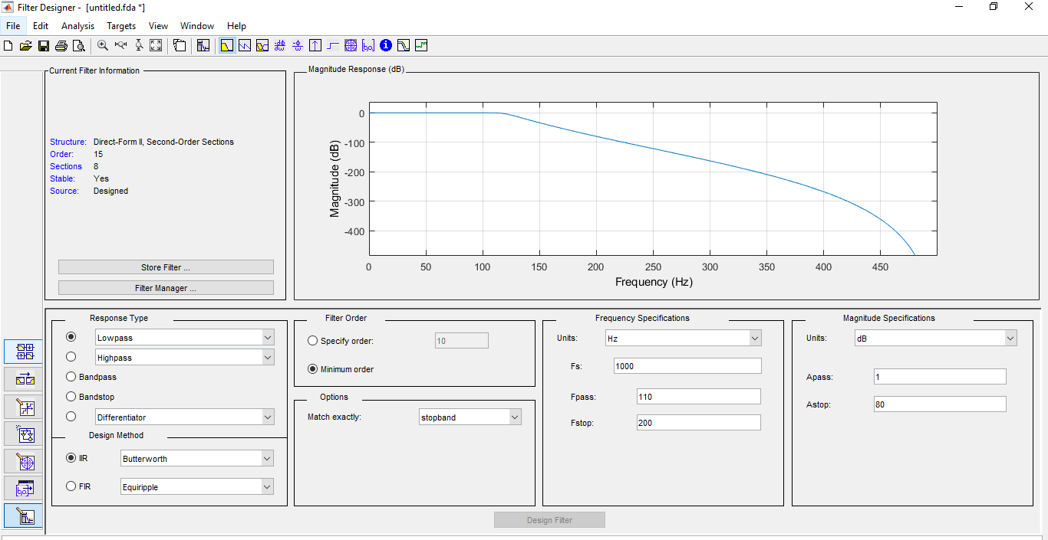

***Magnitude Response:***

***Group Delay:***

***Impulse Response:***

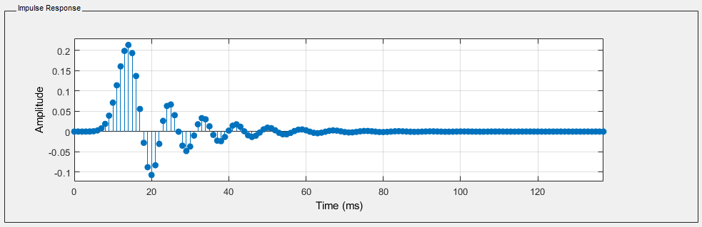

***Pole-Zero Plot:***

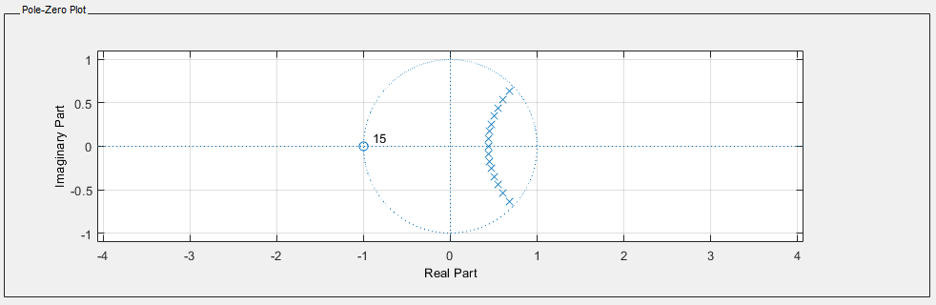

***Explanation:***



**Exercise**

**4**

Design a bandpass

FIR

filter that

would only pass

a band of frequencies from 200 to

300

Hz

of the signal in Exercise 2.

Apply

the

filter

to

the

signal

and

show

that

the

other

frequency

components

are

suppressed.

***Bandpass FIR Filter:***

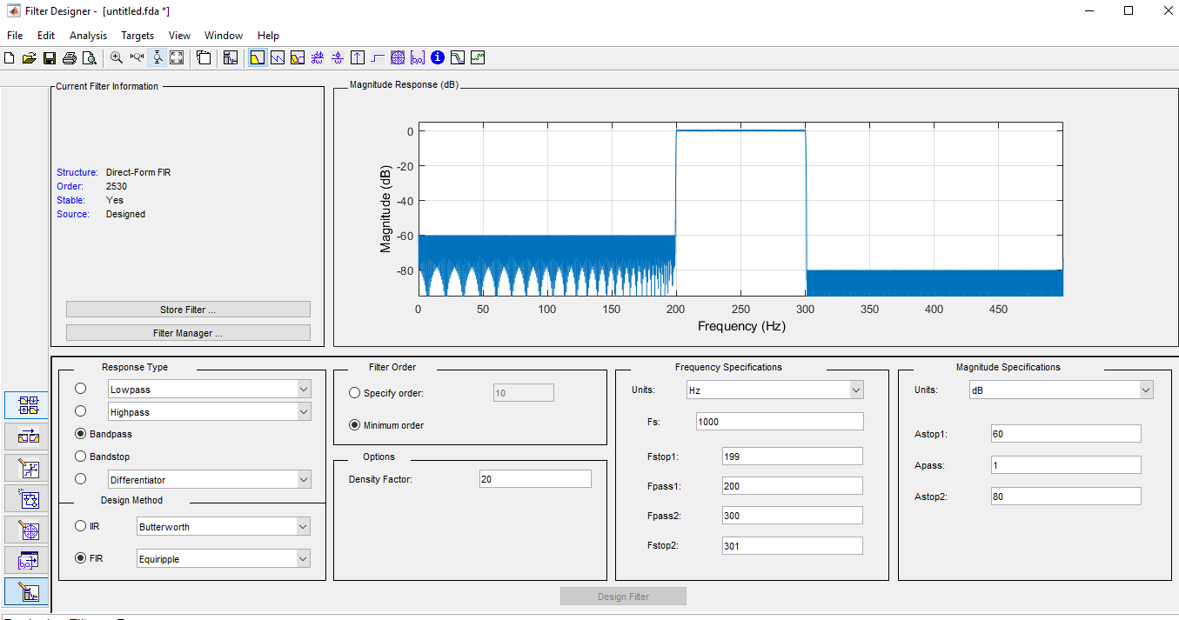

***Magnitude Response***

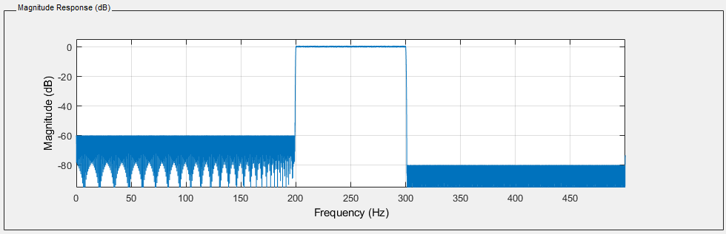

***Group Delay:***

***Impulse Response:***

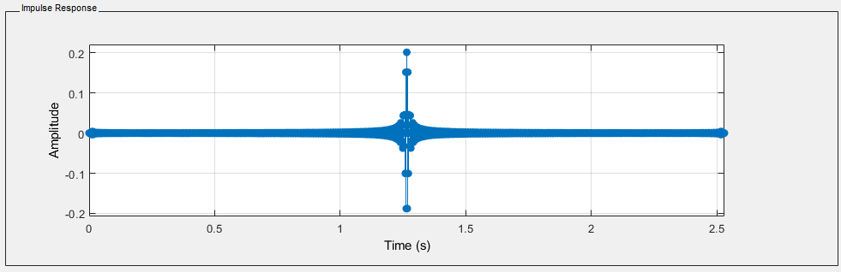

***Pole-Zero Plot:***

|  |
| --- |
| **MATLAB Code:**  clc, clear all:  % Define parameters  fs = 1000;  f1 = 100;  f2 = 200;  f3 = 300;  % Time vector  t = 0:1/fs:(100/f3)-(1/fs);  % Generate signals  x1 = 1*cos(2*pi*f1*t);  x2 = 2*cos(2*pi*f2*t);  x3 = 3*cos(2*pi*f3*t);  y = x1 + x2 + x3;  % Plot original signal in time domain  figure(1);  subplot(2, 1, 1);  plot(t,y);  xlabel('Time (s)');  ylabel('Signal Amplitude');  title('Original Signal');  % Calculate frequency response of original signal (FFT)  Y = fft(y);  f = linspace(0, fs/2, length(Y)/2+1);  % Plot frequency response of original signal  subplot(2, 1, 2);  plot(f, abs(Y(1:length(f))))  xlabel('Frequency (Hz)');  ylabel('Magnitude');  title('Frequency Response of Original Signal');  % Apply filter  filtered_y = filter(Fahim y);  % Plot filtered signal in time domain  figure(2);  subplot(2, 1, 1);  plot(t,filtered_y);  xlabel('Time (s)');  ylabel('Filtered Signal Amplitude');  title('Filtered Signal');  % Calculate frequency response of filtered signal (FFT)  Y_filtered = fft(filtered_y);  % Plot frequency response of filtered signal  subplot(2, 1, 2);  plot(f, abs(Y_filtered(1:length(f))))  xlabel('Frequency (Hz)');  ylabel('Magnitude');  title('Frequency Response of Filtered Signal'); |
| **Output:** |

***Explanation:***



**Exercise**

**5**

Design a

bandstop

FIR

filter

that

would

stop

the

band of frequency 100 to 200

Hz

of

the

signal in Exercise 2.

Apply the filter to the signal and show that the frequency

component is

suppressed,

while the others are passed.

***Bandstop FIR Filter:***

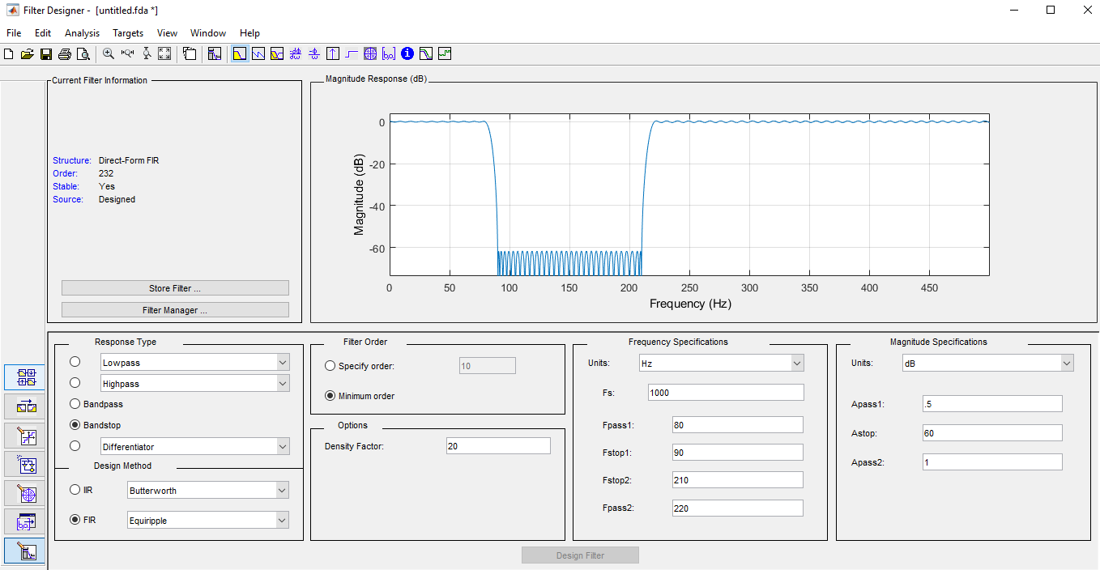

***Magnitude Response:***

***Group Delay:***

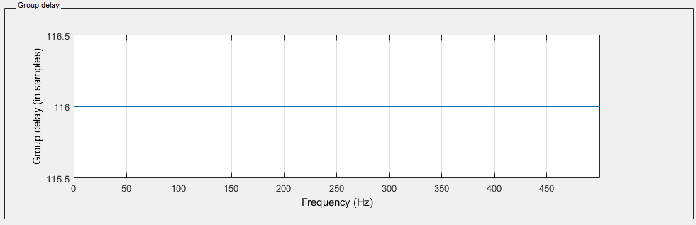

***Impulse Response:***

***Pole-Zero Plot:***

|  |
| --- |
| **MATLAB Code:**  clc, clear all:  % Define parameters  fs = 1000;  f1 = 100;  f2 = 200;  f3 = 300;  % Time vector  t = 0:1/fs:(100/f3)-(1/fs);  % Generate signals  x1 = 1*cos(2*pi*f1*t);  x2 = 2*cos(2*pi*f2*t);  x3 = 3*cos(2*pi*f3*t);  y = x1 + x2 + x3;  % Plot original signal in time domain  figure(1);  subplot(2, 1, 1);  plot(t,y);  xlabel('Time (s)');  ylabel('Signal Amplitude');  title('Original Signal');  % Calculate frequency response of original signal (FFT)  Y = fft(y);  f = linspace(0, fs/2, length(Y)/2+1);  % Plot frequency response of original signal  subplot(2, 1, 2);  plot(f, abs(Y(1:length(f))))  xlabel('Frequency (Hz)');  ylabel('Magnitude');  title('Frequency Response of Original Signal');  % Apply filter  filtered_y = filter(Shah, y);  % Plot filtered signal in time domain  figure(2);  subplot(2, 1, 1);  plot(t,filtered_y);  xlabel('Time (s)');  ylabel('Filtered Signal Amplitude');  title('Filtered Signal');  % Calculate frequency response of filtered signal (FFT)  Y_filtered = fft(filtered_y);  % Plot frequency response of filtered signal  subplot(2, 1, 2);  plot(f, abs(Y_filtered(1:length(f))))  xlabel('Frequency (Hz)');  ylabel('Magnitude');  title('Frequency Response of Filtered Signal'); |
| **Output:** |

***Explanation:***

***Conclusion:***

### Evaluation Rubric

* **Method of Evaluation**: In-lab marking by instructors, Report submitted by students
* **Measured Learning Outcomes**:

CLO1: Develop algorithms to perform signal processing techniques on digital signals using MATLAB and DSP Kit DSK6713 CLO3: Deliver a report/lab notes/presentation/viva, effectively communicating the design and analysis of the given problem

|  |  |  |  |  |  |  |
| --- | --- | --- | --- | --- | --- | --- |
|  | Excellent 10 | Good  9-7 | Satisfactory 6-4 | Unsatisfactory 3-1 | Poor 0 | Marks Obtained |
| Tasks (CLO1) | All tasks completed correctly. Correct code with proper comments. | Most tasks completed correctly. | Some tasks completed correctly. | Most tasks incomplete or incorrect. | All tasks incomplete or incorrect. |  |
| Output  (CLO1) | Output correctly shown with all Figures/Plots displayed  as required and properly  labelled | Most Output/Figures/Plots displayed with proper labels | Some Output/Figures/Plots displayed with proper labels  OR Most Output/Figures/Plots displayed but without proper  labels | Most of the required  Output/Figures/Plots not displayed | Output/Figures/Plots not displayed |  |
| Answers (CLO1) | Meaningful answers to all questions. Answers show the understanding of the student. | Meaningful answers to most questions. | Some correct/ meaningful answers with some irrelevant ones | Answers not understandable/ not relevant to questions | Not Written any Answer |  |
| Report  (CLO3) | Report submitted with proper grammar and  punctuation with proper  conclusions drawn and good  formatting | Report submitted with proper conclusions drawn with good formatting but  some grammar mistakes OR proper grammar but not very good formatting | Some correct/ meaningful conclusions. Some parts of the document not properly  formatted or some grammar  mistakes | Conclusions not based on results. Bad formatting with no proper grammar/punctuation | Report not submitted |  |
|  |  |  | Total | | |  |